

**DEDAN KIMATHI UNIVERSITY OF TECHNOLOGY**

**SCHOOL OF ENGINEERING**

**DEPARTMENT OF ELECTRICAL AND ELECTRONIC ENGINEERING**

**BACHELOR OF SCIENCE IN ELECTRICAL AND ELECTRONIC ENGINEERING**

**FINAL YEAR PROJECT REPORT**

**REMOTE MONITORING AND CONTROL OF A SMALL SCALE PV SOLAR BACK UP SYSTEM**

**PRESENTED BY:**

**MULWA FRANCIS MAINGI E021-01-0837/2016**

**NGUGI TIMOTHY NDUATI E021-01-2091/2016**

**DATE:**

**ACADEMIC YEAR 2020/2021**

**PROJECT SUPERVISOR: DR. NGETHA**

**A project report submitted to Dedan Kimathi University of Technology in partial**

**fulfilment of the requirement for the award of the Bachelor of Science Degree in Electrical and Electronic engineering.**

# 

# DECLARATION

This project is our original work, except where due acknowledgement is made in the text, and to the best of our knowledge has not been previously submitted in this or any other university for the award of the degree.

Signature: Date:

MULWA FRANCIS MAINGI E021-01-0837/2016

Signature: Date:

NGUGI TIMOTHY NDUATI E021-01-2091/2016

SUPERVISOR

This project has been submitted to the Department of Electrical and Electronic Engineering, in Dedan Kimathi University of Technology, with my approval as the supervisor:

Signature: Date

Dr. Harrison T. Ngetha

# DEDICATION

We would like to dedicate this project to our families who have always stood by our side and offered counsel at all stages. May God guide you and bless you.

# ACKNOWLEDGEMENT

We thank God for giving us the strength, courage and knowledge to complete this project.

We also thank Dr. Ngetha, our supervisor, who has been there to guide and motivate us in the choice of the project and on the progressive development of the same. The assistance he has offered has been very instrumental in meeting the set objectives.

# ABSTRACT

PV solar standby power back up can be used as convenient way to supplement the electrical energy in case the grid supply is un available. To realize this, we designed a system of standby power controller with GSM. The power outlet monitors the voltage on the batteries and completely cuts off the power supply when the monitored power is below the threshold. This power outlet has a function of changing the threshold power, which enables any kind of home appliances to be applied to the power outlet. To efficiently manage the power outlets, a GSM controller is used. A user can monitor the power outlet locally at the vicinity of the GSM. The system provides remote monitoring of the system.

# TABLE OF CONTENT

DECLARATION ii

DEDICATION iii

ACKNOWLEDGEMENT iv

ABSTRACT v

TABLE OF CONTENT vi

LIST OF FIGURES vii

LIST OF TABLES viii

CHAPTER ONE: INTRODUCTION 9

1.0 BACKGROUND 9

1.1 PROBLEM STATEMENT 1

1.2 AIMS AND OBJECTIVES 2

1.2.1 MAIN OBJECTIVES 2

1.2.2 SPECIFIC OBJECTIVES 2

1.3 JUSTIFICATION 2

CHAPTER TWO: LITERATURE REVIEW 2

2.1 POWER BACKUP SYSTEM 2

2.1.1 FUEL-POWERED GENERATOR 3

2.1.2 WIND GENERATOR 3

2.1.3 BATTERY BACKUP SYSTEM 3

2.2 SOLAR POWER 3

2.3 REMOTE MONITORING AND CONTROL 4

2.4 RELATED WORKS 4

CHAPTER THREE: METHODOLOGY 5

3.1 OVERVIEW 5

3.2 SOLAR PV INSTALLATION 6

3.3 VOLTAGE AND CURRENT TRANSDUCERS 7

3.4 TEMPERATURE SENSOR 7

3.5 LOW COST MICROCONTROLLER 8

3.6 GSM MODULE 9

3.7 CHANGEOVER SWITCH 10

3.8 WORKING OF THE SYSTEM 10

CHAPTER FOUR: EXPECTED RESULTS 12

REFERENCES 13

APPEDIX 14

# 

# LIST OF FIGURES

Figure 1: Schematic Diagram of Solar Photovoltaic Remote Monitoring Systems 13

Figure 2: 40 W solar panel installation 14

Figure 3: Hall Effect Current sensor 14

Figure 4: Temperature Sensor LM35 14

Figure 5: Arduino UNO Microcontroller board 15

Figure 6: SIM 900A GSM Module 16

Figure 7 Relay 16

Figure 8: flow chart of the system 17

# LIST OF TABLES

Table 1: BUDGET 22

Table 2: TIME PLAN 23

# CHAPTER ONE: INTRODUCTION

## 1.0 BACKGROUND

Currently, the problem of power outage in the country has become an inevitable problem that scientists and researchers have for a long period of time being researching on alternative ways on which the power supply provision can be made more stable and reliable both in domestic and industrial use. The need of having available sustainable energy generation systems for replacing gradually conventional ones requires the improvement of structures of energy supply based mostly on clean and renewable energy resources [1].

A hybrid system has therefore been established where grid power supply is supplemented by a Photovoltaic (PV) power supply using the same infrastructure system network. PV system basically comprises of; Power generator (solar panel), storage battery, charge controller and an inverter. A PV system is able to supply electric energy to a given load by directly converting solar energy through the photovoltaic effect. The system structure is very flexible. PV modules are the main building blocks; this can be arranged into an array to increase electric energy production. Normally additional equipment is necessary in order to transform energy into useful form or store energy for future use. The hybrid system is the PV system and grid system coupled together using a manual or automatic change over switch.

At present, solar photovoltaic (PV) generation is assuming increased importance in application because of distinctive advantages such as simplicity of allocation, high dependability, absence of fuel cost, low maintenance and lack of noise and wear due to the absence of moving parts. Furthermore, the solar energy characterizes a clean, pollution free and inexhaustible energy source. In addition to these factors are the declining cost and prices of solar modules, an increasing efficiency of solar cells, manufacturing-technology improvements and economies of scale. Even more, this trend is also expected to be increased, sustained by the development of new power electronics technologies, new circuit topologies and control strategies [2]-[3].

To control and manage this system different technologies have been used. ZigBee network of technology in renewable energy has mostly been used and extended to home energy solutions and other fields of the future smart grid where the control and management of the system can be done remotely.

## 1.1 PROBLEM STATEMENT

The problem that we have currently is that, there is minimal conversional knowledge on how to incorporate advanced technologies, sophisticated control strategies and integrated digital communications into the existing electricity grid that has initiated a new revolution in the power sector through the emergence of the Smart Grids (SGs). Smart grids have begun to radically change the way electricity is produced, consumed and distributed.

A SG is an electricity transmission and distribution network that has the ability to rapidly assimilate, simplify and understand large amounts of information and use it correctly, by making intensive use of both, automation and information and communication technologies (ICTs) [4].

## 1.2 OBJECTIVES

### 1.2.1 MAIN OBJECTIVE

To develop a remotely monitored and controlled small scale PV solar back up system.

### 1.2.2 SPECIFIC OBJECTIVES

1. To design an Arduino circuit that read the voltage level, current, temperature of the battery.
2. To design an Arduino circuit that automatically switches from grid supply to solar and vice versa.
3. To design a GSM system that monitors the voltage, current and temperature and sends the sensors’ values as an alert SMS.

## 1.3 JUSTIFICATION

The current national grid power supply is encounter by frequent power outage in Kenya. In both domestic and commercial industry, the need of sustainable power is necessary. A back up system provides the need power in case of a power outage. Various backup systems such as diesel has been used before which pollute the environment. Where back up power has been used to change the supply from the national grid to the backup power and vice versa is time consuming and need a specialist in some instances thus an increasing in cost. A remotely controlled pave solar power back up system will insure a continuous supply of power with low cost and environmentally friendly.

# CHAPTER TWO: LITERATURE REVIEW

## 2.1 POWER BACKUP SYSTEM

A backup system is used to provide energy when the primary source fails. This system is very important since an interruptible power supply is very crucial for any operation. Black outs can happen at any time of the year and many home owners want the assurance that a backup power system offers. Commonly used backup power options for home electrical system are discussed below.

### 2.1.1 FUEL-POWERED GENERATOR

Fuel-powered generator can either portable generator or fixed generator. A portable generator requires a constant source of fuel, most often diesel or gasoline. This fuel must be stored properly and does provide emissions during use. Portable generator also tends to be loud and need to be set up outside while in use. When space and budget permits, a permanent or fixed generator makes good sense. Run on diesel or gasoline fuel, this system is much mor like portable generator, but handles larger loads and cannot be moved.

### 2.1.2 WIND GENERATOR

Wind turbines can be used in locations with the proper zoning and weather patterns. Installing a wind turbine in an area with little wind exposure does not make economic sense, but this solution presents several benefits to certain properties. This system does not require regular maintenance. Prices range depending on the size of turbine and location.

Wind does not blow at a constant speed, and therefore power generation must be transferred to a battery bank via an inverter. A separate breaker panel should be installed and in certain circumstances, the power can be fed back into the grid through a reverse meter.

### 2.1.3 BATTERY BACKUP SYSTEM

A traditional type of backup power still used by many, a battery backup system can handle both AC and DC loads, depending on the design. Single battery systems work well for power outages lasting only a few hours, while larger battery bank system or those that utilize a vehicle battery can provide steady power for one to two days.

Battery backup systems require an inverter and some require a charger. Quality systems also provide protection against overheating, a common problem with this type of generator. Look for products with a deep cycle battery for better dependability. Grounding is essential for safety.

## 2.2 SOLAR POWER

Renewable energy sources are gaining in popularity and small residential systems are now available for a reasonable investment. A single panel or multiple panel PV (photovoltaic) solar generator mount directly to the roof or ground-mount framing.

Solar panels produce DC electricity, and should be used to power up DC appliances and lighting. Some home owners also add an inverter to expand the function of this backup system a twin panel or multiple panel system is required to power appliances like microwave.

Battery banks make these systems more practical, but must be maintained and replaces every eight to ten years. This backup system is permanently installed in a secure, dry location with conduits and wires connecting the inverter, panels and separate panel board.

## 2.3 REMOTE MONITORING AND CONTROL

A major concept related to solar energy and PV systems is remote monitoring. Remote monitoring is on-line real-time monitoring and controlling the field equipment, transmitting the real-time picture and testing data to the terminal to forecast or diagnose. The remote monitoring system have to obtain, analyze, transmit, manage and feedback the remote goal information, by combining the most advanced science and technology field of communication technology and other areas. It is also the comprehensive usage of instrumentation, electronic technology and computer software.

Current monitoring PV system approaches present some problems like low automaticity and poor real-time. These problems can advantageously be solved with an efficient remote environment information monitoring and controlling system. This system should include automatic diagnosis techniques with quick and efficient responses between the central PV monitoring and control station and the smart PV station.

## 2.4 RELATED WORKS

Photovoltaic systems have recently attracted more attention as prominent renewable energy source. Several systems of remote monitoring and PV controlling have already been reported in the recent literature. Wireless sensor network has been widely adopted in PV system since it is possible to make complex maintenance. A predictive maintenance comprises localization and definition of related faults. Localization of failures in a PV system is very important in any condition. In what follows we will only concentrate on the mostly used ones.

In 2011, X. Xiaoli et *al*. proposed a remote monitoring and control of PV system based on Zigbee technology. Despite the efficiency of this method, it can’t face up huge distances.

Another alternative was suggested in 2013 by P. Bauer et al. it consist in implementing remotely accessible solar energy programs using internet support. The authors admit that this method has some execution delay caused by application complexity. Besides, the main handicap of this solution is the lack of internet support especially in cut-off sites.

In_ the authors, presented a remote monitoring and control PV system based on Wi-Fi technology for domestic applications. Thus, Wi-Fi (IEEE 802.11g) is selected as it operates at 2.4GHz and offers high data rate of about (54Mbps) compares with ZigBee (250Kbps). But this solution is only working in a micro grid network architecture.

This has motivated our approach to investigate a novel remote monitoring and control of PV system based on GSM to avoid the enormous problems faced in the literature. We will describe our proposed solution in more details in what follows.

# CHAPTER THREE: METHODOLOGY

## 3.1 OVERVIEW

The concept of our proposed system is to identify the state of a photovoltaic system through a sensors network in order to control it remotely. The information from the sensors is sent over on mobile networks to the internet for data logging and review by the user. In case of a deviation from normal specified values of voltage or temperature, the system automatically switches to the alternative supply and alerting the user via an SMS.

The voltage is sensed by voltage divider circuit. Current is sensed using Hall Effect Current Sensor. The temperature is sensed using LM35 temperature sensor. The data obtained is processed using Arduino Uno microcontroller and sent as serial input to the SIM 900 GSM module. The GSM module sends the data over as an alert SMS for remote monitoring.

Schematic diagram of the system is shown in figure below.

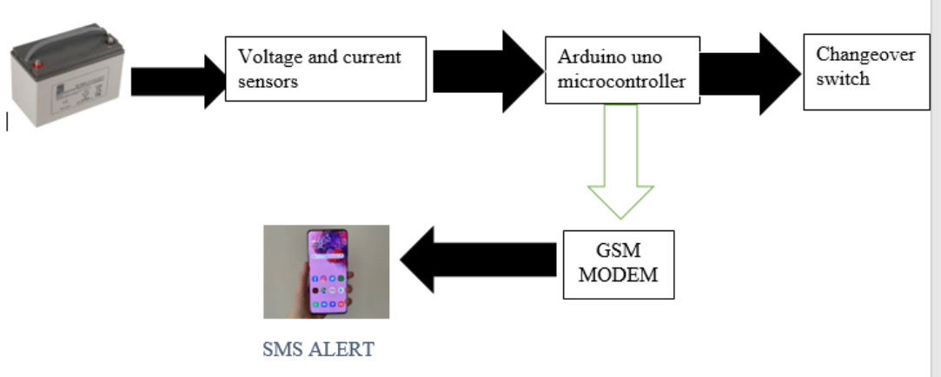

Figure 1: Schematic Diagram of Solar Photovoltaic Remote Monitoring Systems

Components of the solar PV remote monitoring and control

## 3.2 SOLAR PV INSTALLATION

An installation of one 40W solar panel, show in figure is used to provide the required output to be measured. These have maximum power output of 125 W, maximum voltage of 12V

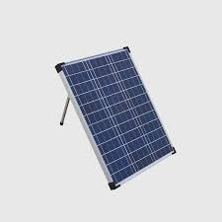

Figure 2: 40 W solar panel installation

## 3.3 VOLTAGE AND CURRENT TRANSDUCERS

The solar PV voltage is sensed using a voltage divider circuit. Current is sensed using Hall Effect Current Sensor. Hall Effect is the generation of potential difference due to a current carrying conductor in a perpendicular magnetic field. Hall Effect current sensors works on this principle.



Figure 3: Hall Effect Current sensor

## 3.4 TEMPERATURE SENSOR

The LM35 Integrated Circuit Temperature Sensor is used to measure the ambient temperature. It gives very accurate readings in Degree Celsius for over a range of 0-100oCwhile drawing very low current of about 60 micro Amps.



Figure 4: Temperature Sensor LM35

## 3.5 LOW COST MICROCONTROLLER

In this proposed conceptual system, Arduino board acts as a microprocessor which processes the incoming data from various sensors. This board is selected because it reduces the requirement of various components like constant DC voltage regulator, burner hardware and does not require a separate software to convert the code hex file and burn it in the microprocessor. All work is done by Arduino IDE and is burnt in Arduino board via a USB chord.

Arduino Uno is a microcontroller board based on ATmega328P processor. It can be coded as required using Arduino IDE in C/C++ language and uploaded directly to the board. This board has a plethora of applications in the field of embedded electronics. This is where it is decided whether the values obtained by various sensors are within limit depending upon the logic code given to Arduino board.

It processes the incoming data from various sensors and sends them to the GM module via serial communication protocol along AT commands necessary for the operation of GSM module and operates the changeover switch.



Figure 5: Arduino UNO Microcontroller board

## 3.6 GSM MODULE

SIM 900A GSM Module is used in this proposed conceptual system. It is very reliable wireless module. Its attributes are its small size, low cost and low power consumption. It delivers GSM/GPRS 900/1800 MHz performance for voice, SMS, Data and Fax.

In this system, it acquires the data to be sent to the user from Arduino board serial communication along with the necessary AT commands and sends the data on the internet on a self-created Ip address. The user can enter this IP address on his system and get real time state condition of the system.

GSM module is chosen over Zigbee module because Zigbee technology is proven inefficient because it can’t face huge distances.



Figure 6: SIM 900A GSM Module

## 3.7 CHANGEOVER SWITCH

The changeover switch is a device used to switch off a power supply and consequently switch on another power supply and subsequently switch on another power supply. Basically, it is aimed at switching on a more convenient power supply to the load. In this project we are going to control a relay using Arduino UNO.

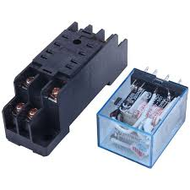

Figure 7 Relay

## 3.8 WORKING OF THE SYSTEM

The major role of this system is to send the data as an alert system through GPRs enabled modem and switch between grid supply and solar power. GPRs services of the modem are initiate using the AT commands along with the IP address and corresponding port. Values from various sensors are taken by the Arduino boar and sent to the modem as a single string which should be separated by commas or colons. The data is compared to the set threshold and the Arduino triggers the changeover switch if met. The flow chart of working of the system is shown in figure

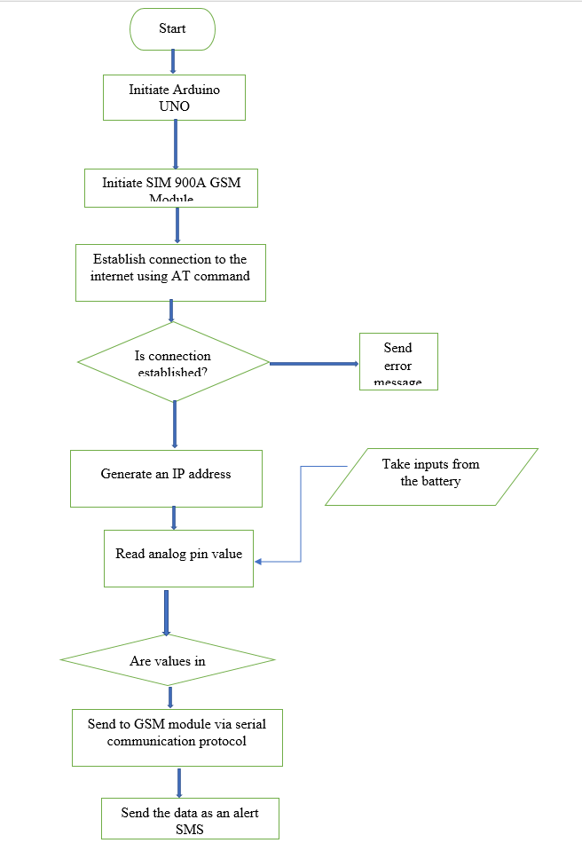

Figure 8: flow chart of the system

The data is sent to a target server PC through the static IP. A data logging software will be running on the target PC and the data received from the GPRS module in ASCII format will be stored in a text file.

A standalone web hosting service will also be running on the target PC which would enable the user to access the data and monitor the system anywhere on the globe using internet connection.

# 

# CHAPTER FOUR: RESULTS AND ANALYSIS

Accomplishments

The second objective has completely been met whereas the first and the third objectives have been partially met through simulations using Proteus software.

THE SECOND OBJECTIVE RESULTS

The Arduino reads the output voltage value of the voltage divider, if both the battery and grid supply are available or grid supply is out, the solar relay is engaged otherwise the grid relay comes on.

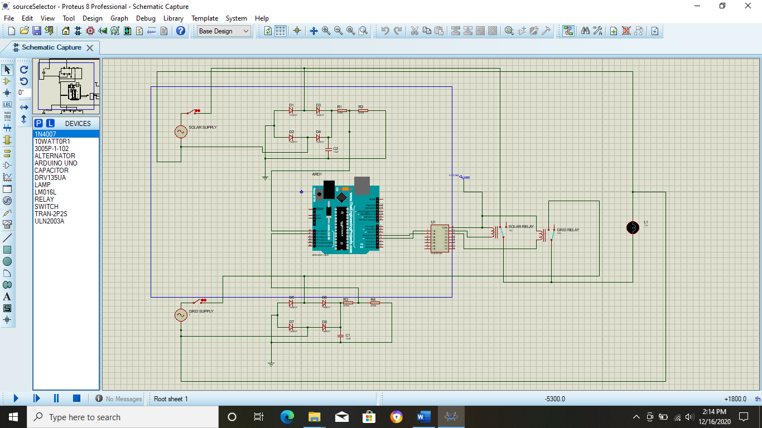

Figure 1; schematic diagram of an automatic change over switch

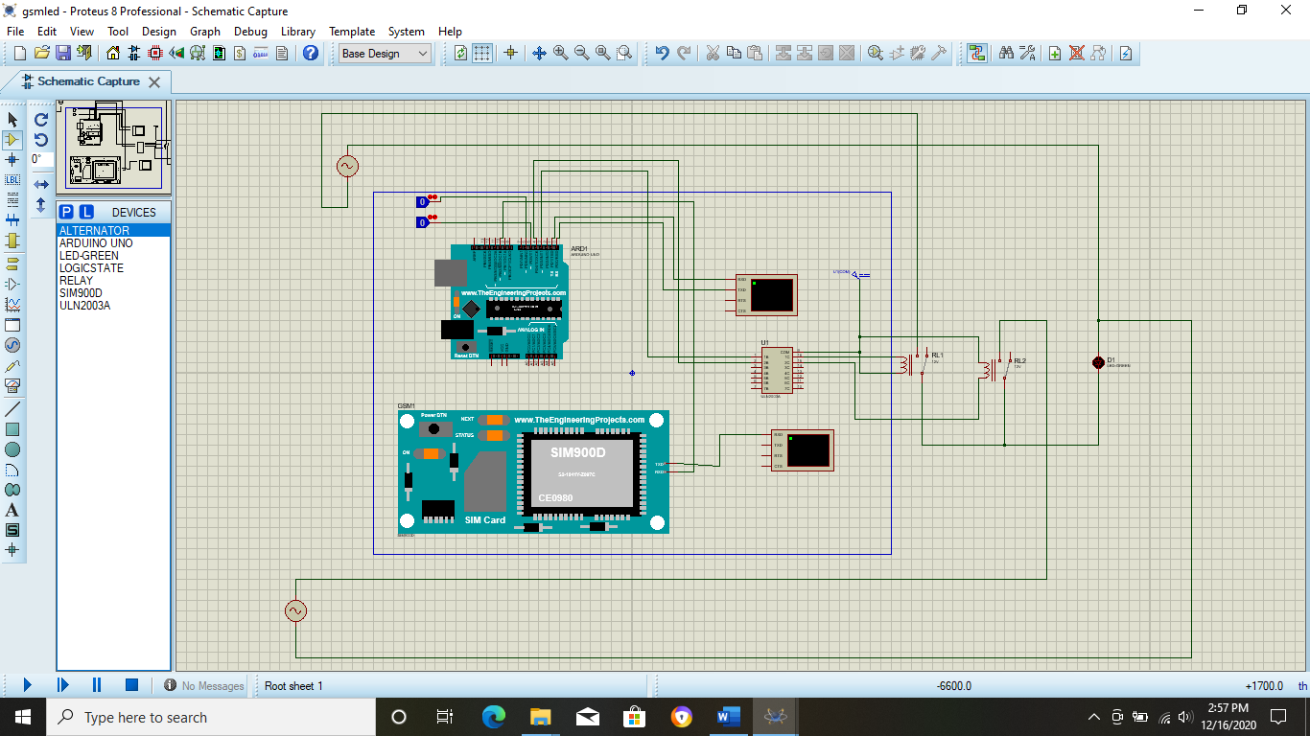

Figure 2 An SMS controlled change over switch

In case the automatic change over switch fails, an SMS can be used to switch between the supplies

First objective results

The Arduino reads the current value from the current sensor and sends an SMS through GSM module Sim900. This partially meets objective one and three.

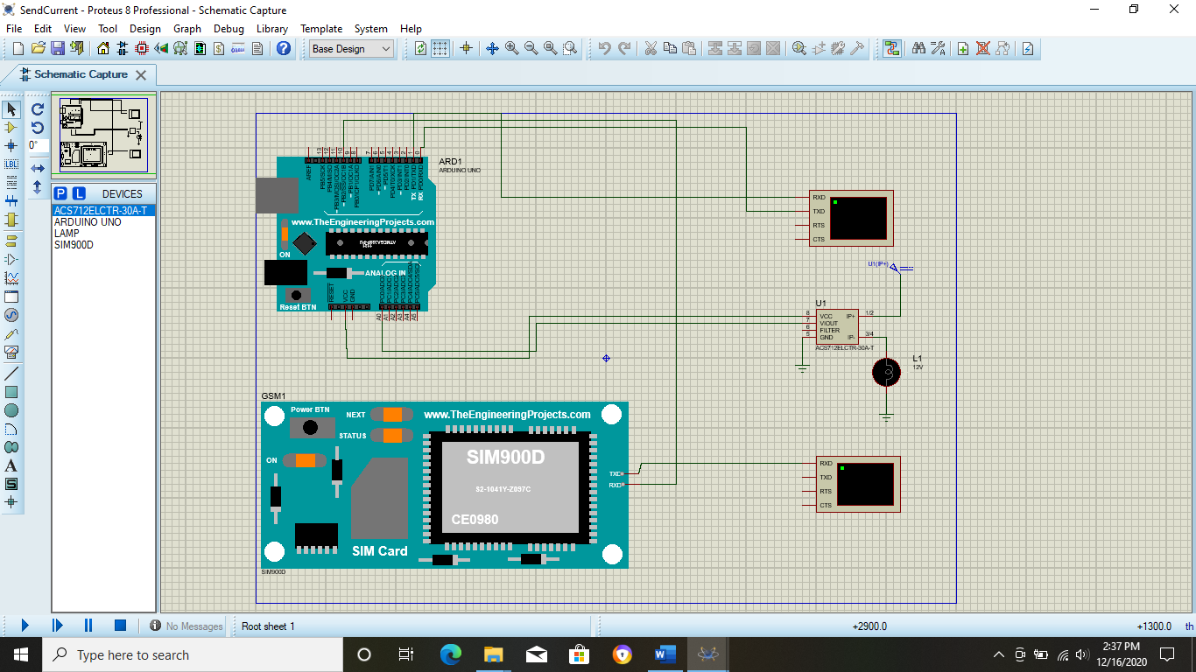

Figure 3; schematic diagram of current sensor

The storing of data to the server of objective three is yet to be established since actual implementation is required.

# REFERENCES

[1] R. Operation, “( 12 ) Patent Application Publication ( 10 ) Pub . No .: US 2012 / 0126699 A1,” vol. 1, no. 19, 2012.

[2] S. B. Pollack and D. L. Kaplan, “(12) Patent Application Publication (10) Pub. No.: US 2008/0039979 A1,” vol. 1, no. 19, 2008.

[3] L. D. Humphrey and I. Gb, “( 12 ) United States Patent,” vol. 2, no. 12, 2016.

[4] I. M. Simmons, W. M. Simmons, N. C. Us, J. F. Preta, F. L. Us, and D. J. Preta, “( 12 ) United States Patent Main-power ( J i,” vol. 2, no. 12, 2014.

[5] T. Chen, A. Hsu, and T. Hsien, “(12) United States Patent,” vol. 2, no. 12, 2012.

[6] R. Cited, “( 12 ) United States Patent Control agementir,” vol. 2, no. 12, 2014.

# APPEDIX

REMOTE MONITORING AND CONTROL OF HOME-BASEDPV SOLAR BACKUP SYSTEM PROJECT BUDGET

|  |  |
| --- | --- |
| **NAME** | **REG NO:** |
| Mulwa Francis Maingi | E021-01-0837/2016 |
| Ngugi Timothy Nduati | E021-01-2091/2016 |

THE PROPOSED BUDGET.

Table 1: BUDGET

|  |  |  |  |  |  |  |
| --- | --- | --- | --- | --- | --- | --- |
| **NO** | **Item** | **Description** | **Quantity** | **Price per Unit** | **Amount** | **Total *(Ksh)*** |
| 1 | Microcontroller | Arduino Uno | 1 | 1500 | 1500x1 | 1150 |
| 2 | Solar panel | 40Watts, 12V | 1 | 2050 | 1x2050 | 2050 |
| 4 | Resistors | 1M  100k  10k | 3  3  3 | 10  10  10 | 3x10  3x10  3x10 | 30  30  30 |
| 5 | GSM Module | Sim900A | 1 | 1700 | 1700x1 | 1700 |
| 9 | Connecting  wires | Jumper | 100pcs | 300 | 300 | 300 |
| 10 | Terminal connector | 4x1 | 2 | 150 | 150x2 | 300 |
| 11 | Rechargeable lead acid battery | 12V | 1 | 2700 | 2700x1 | 2700 |
| 12 | 1. Channel solid state relay | 12V | 2 | 1000 | 1000x2 | 2000 |
| 12 | Temperature sensor | Lm35 | 1 | 150 | 150x1 | 150 |
| 14 | current sensors | 12v | 2 | 500 | 500x1 | 500 |
| **TOTALS** |  |  |  |  |  | **Ksh 10,940** |

Table 2: TIME PLAN

|  |  |
| --- | --- |
| NO | ACTIVITY |
| WEEK 1-3 | INTRODUCTION |
| WEEK 4-6 | LITERATURE REVIEW |
| WEEK 7-10 | METHODOLOGY |
| WEEK 11 | EXPECTED RESULTS |